**MySQL – Query result Assignment**

**Database Name:** Chinook

**Query 1:**

select sum(Total) as TotalSales from invoice;

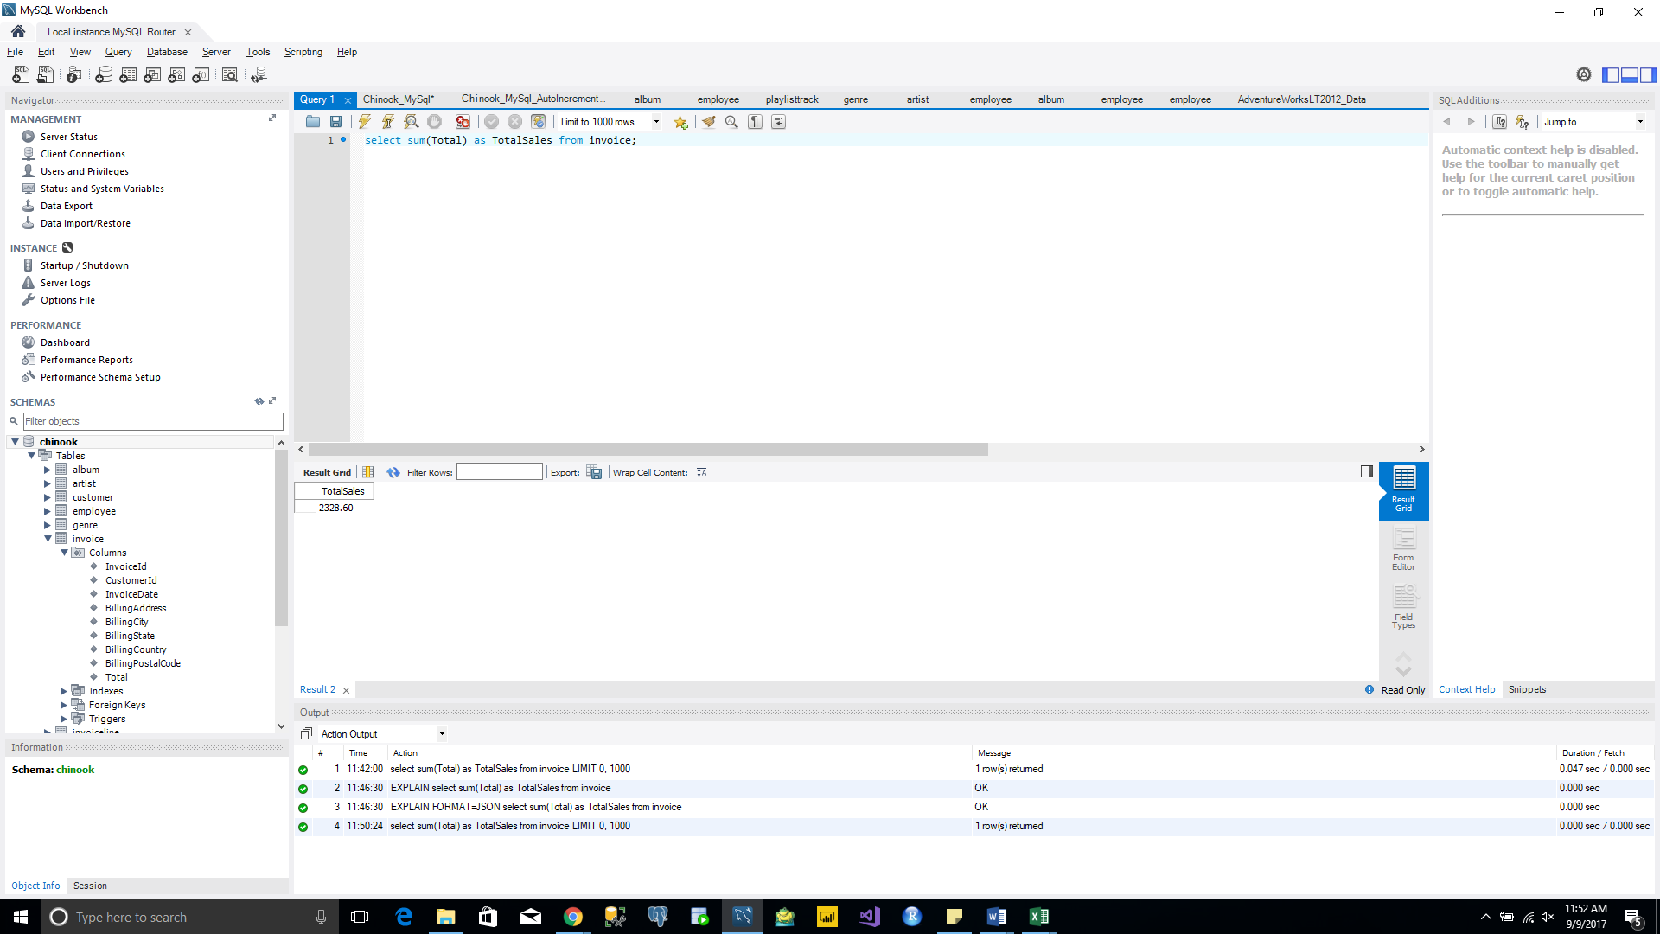

**Query 2:**

set @currank := 0;

set @prerank :=0;

select CountryName, TotalSales,

case

when @prerank = TotalSales then @currank

when @prerank := TotalSales then @currank := @currank +1

end as Rank

from

(select BillingCountry as CountryName, sum(Total) as TotalSales from invoice group by Countryname order by Totalsales desc) as t1;

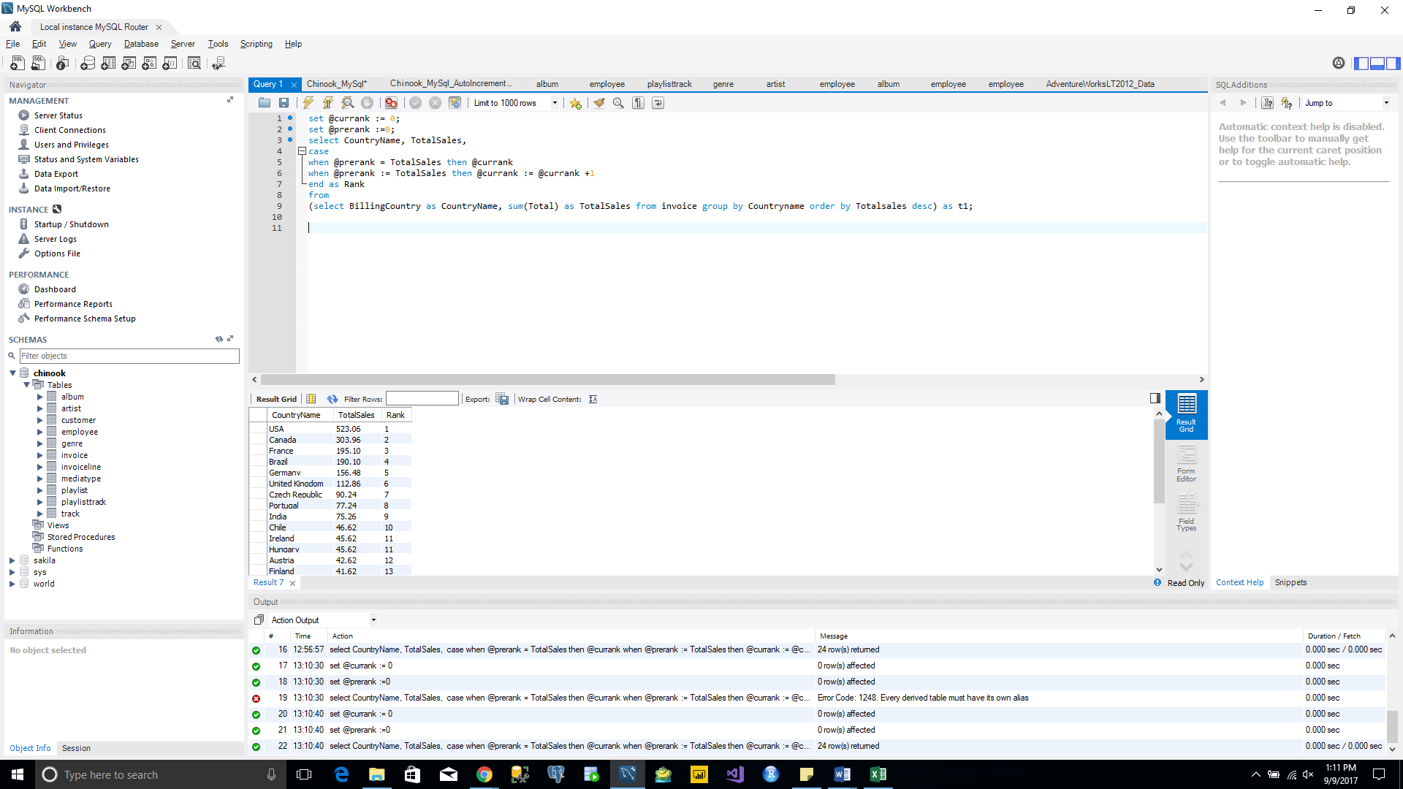

**Query 3:**

select BillingCountry as Country, BillingState as State, Billingcity as City, sum(Total) as Sales from invoice group by Country, State, City order by Sales desc;

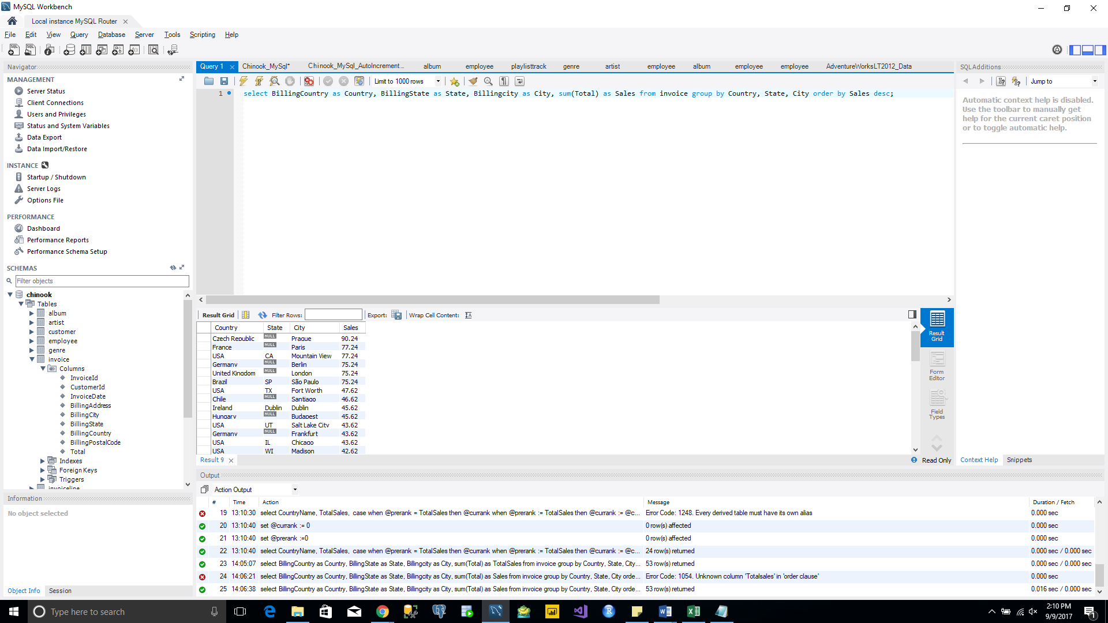

**Query 4:**

select CustomerName, TotalSales,

case

when @prerank = TotalSales then @currank

when @prerank := TotalSales then @currank := @currank + 1

end as Rank

from

(select concat (c.firstname, ' ', c.LastName) as CustomerName, sum(inv.Total) as TotalSales from invoice as inv inner join customer as c on c.CustomerId=inv.CustomerId

group by CustomerName order by TotalSales desc) as t1, (select @currank := 0, @prerank := 0 ) as t2;

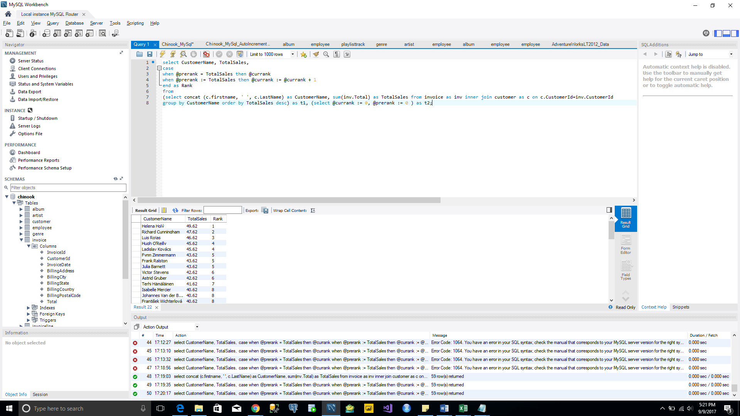

**Query 5:**

select ArtistName, TotalSales,

case

when @prerank = TotalSales then @currank

when @prerank := TotalSales then @currank := @currank + 1

end as Rank

from

(select ar.name as ArtistName, sum(inv.total) as TotalSales from invoice inv inner join invoiceline il on inv.InvoiceId=il.InvoiceId inner join track t on il.TrackId=t.TrackId

inner join album al on t.AlbumId=al.AlbumId inner join artist ar on al.ArtistId=ar.ArtistId group by ArtistName order by TotalSales desc) as t1,

(select @currank:=0,@prerank:=0) as t2;

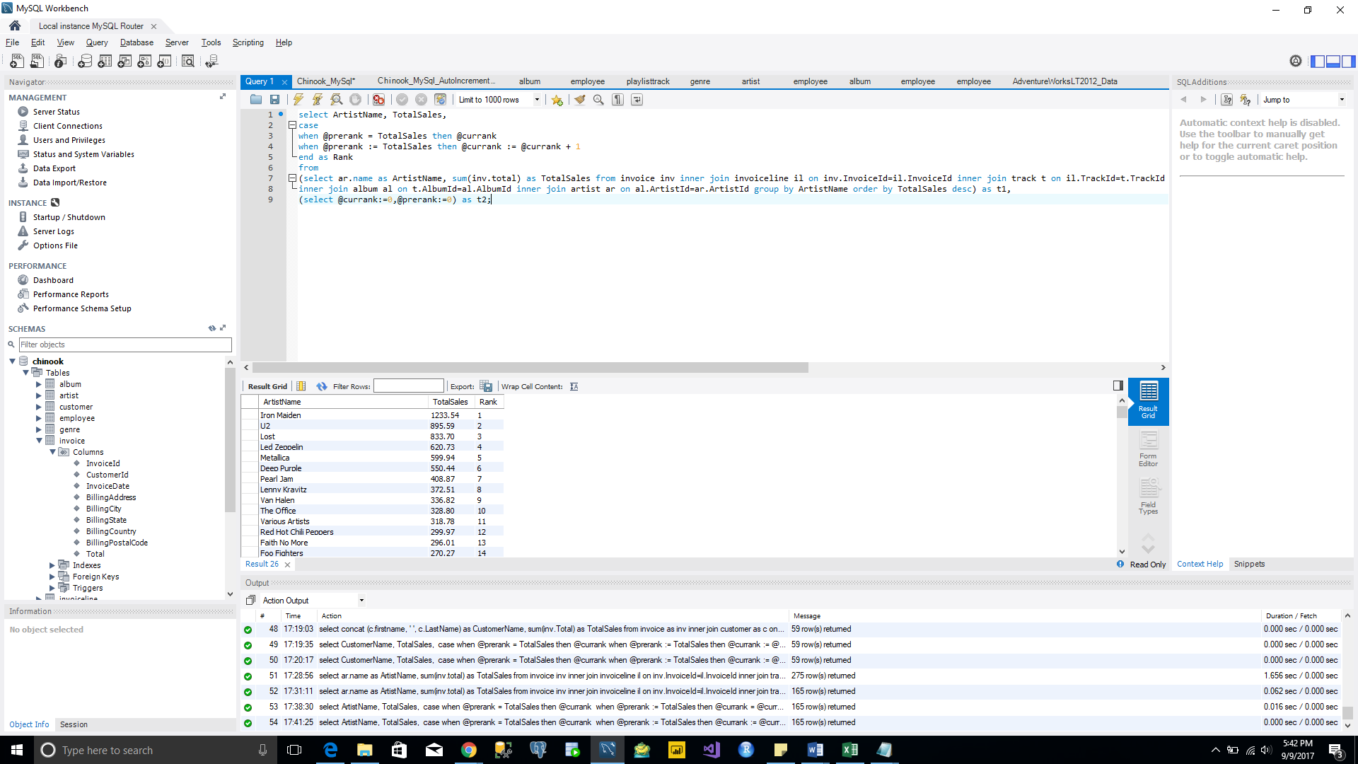

**Query 6:**

select ar.name as ArtistName, al.Title as AlbumTitle, sum(inv.total) as TotalSales from invoice inv inner join invoiceline il on inv.InvoiceId=il.InvoiceId inner join track t on il.TrackId=t.TrackId

inner join album al on t.AlbumId=al.AlbumId inner join artist ar on al.ArtistId=ar.ArtistId group by ArtistName, AlbumTitle order by TotalSales desc;

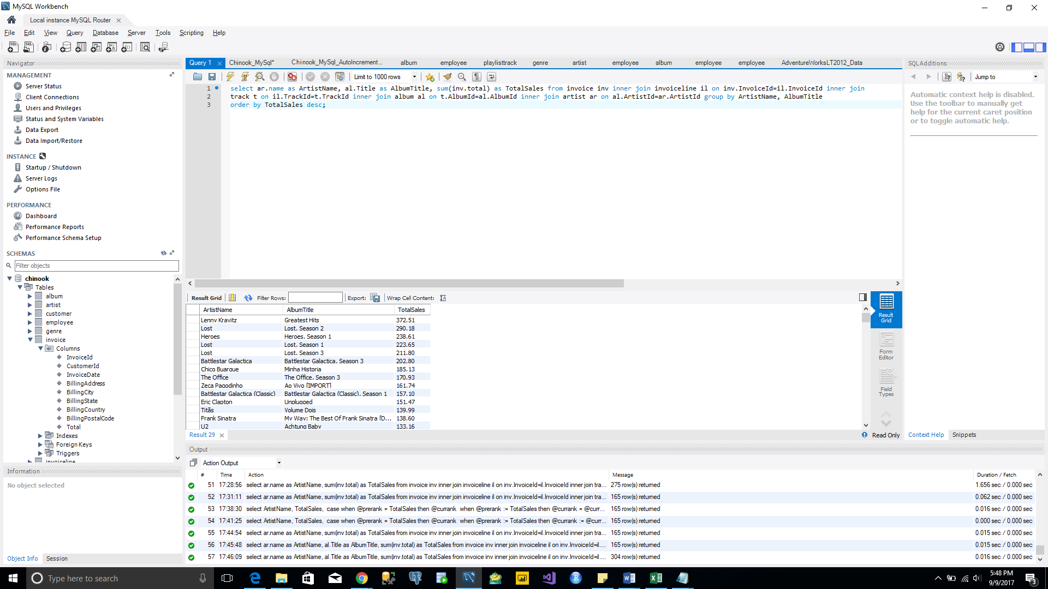

**Query 7:**

select concat(emp.firstname, ' ', emp.LastName) as EmployeeName, sum(inv.Total) as TotalSales from invoice inv inner join customer cus on inv.CustomerId=cus.CustomerId

inner join employee emp on cus.SupportRepId=emp.EmployeeId group by EmployeeName order by TotalSales Desc;

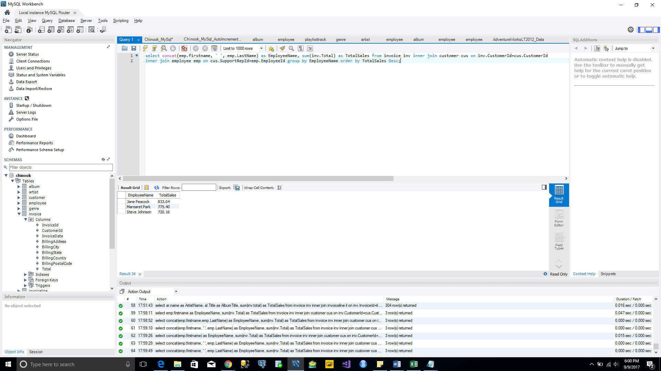

**Query 8:**

select m.name as MediaTypeName, count(t.trackid) as TrackBought, sum(t.UnitPrice) as Cost from mediatype m inner join track t on m.MediaTypeId=t.MediaTypeId

group by MediaTypeName;

